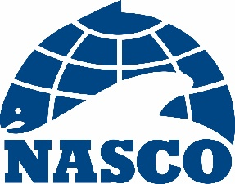

NAC(20)01

Thirty-Seventh Annual Meeting of the North American Commission

Dalmahoy Hotel and Country Club
Edinburgh, Scotland

2 – 5 June 2020

Provisional Agenda

1. Opening of the Meeting
2. Adoption of the Agenda
3. Nomination of a Rapporteur
4. Election of Officers
5. Review of the 2019 Fishery and ACOM Report from ICES on Salmon Stocks in the Commission Area
6. Mixed-Stock Fisheries Conducted by Members of the Commission
7. Sampling in the Labrador Fishery
8. The St Pierre and Miquelon Salmon Fishery
9. Salmonid Introductions and Transfers
10. Announcement of the Tag Return Incentive Scheme Prize
11. Recommendations to the Council on the Request to ICES for Scientific Advice
12. Other Business
13. Date and Place of the Next Meeting
14. Report of the Meeting
15. Close of the Meeting

Secretary
Edinburgh
31 January 2020

