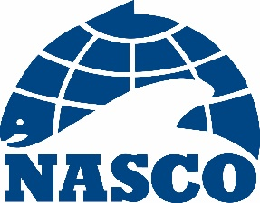

NEA(20)01

Thirty-Seventh Annual Meeting of the North-East Atlantic Commission

Dalmahoy Hotel and Country Club
Edinburgh, Scotland

2 – 5 June 2020

Provisional Agenda

1. Opening of the Meeting
2. Adoption of the Agenda
3. Nomination of a Rapporteur
4. Election of Officers
5. Review of the 2019 Fishery and ACOM Report from ICES on Salmon Stocks in the Commission Area
6. Mixed-Stock Fisheries Conducted by Members of the Commission
7. Regulatory Measures
8. Risk of Transmission of Gyrodactylus salaris in the Commission Area
9. Announcement of the Tag Return Incentive Scheme Prize
10. Recommendations to the Council on the Request to ICES for Scientific Advice
11. Other Business
12. Date and Place of the Next Meeting
13. Report of the Meeting
14. Close of the Meeting

Secretary
Edinburgh
31 January 2020

