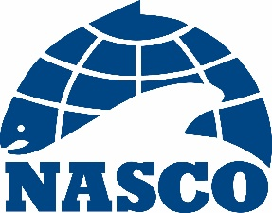

NAC(20)05

Thirty-Seventh Annual Meeting of the North American Commission

By Video Conference

1 – 5 June 2020

Agenda

1. Opening of the Meeting
2. Adoption of the Agenda
3. Election of Officers
4. Review of the 2019 Fishery and ACOM Report from ICES on Salmon Stocks in the Commission Area
5. Mixed-Stock Fisheries Conducted by Members of the Commission
6. Sampling in the Labrador Fishery
7. The St Pierre and Miquelon Salmon Fishery
8. Salmonid Introductions and Transfers
9. Announcement of the Tag Return Incentive Scheme Prize
10. Recommendations to the Council on the Request to ICES for Scientific Advice
11. Other Business
12. Date and Place of the Next Meeting
13. Report of the Meeting
14. Close of the Meeting

