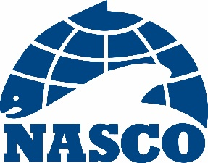

NEA(20)09

Thirty-Seventh Annual Meeting of the North-East Atlantic Commission

By Video Conference

1 – 5 June 2020

Agenda

1. Opening of the Meeting
2. Adoption of the Agenda
3. Election of Officers
4. Review of the 2019 Fishery and ACOM Report from ICES on Salmon Stocks in the Commission Area
5. Mixed-Stock Fisheries Conducted by Members of the Commission
6. Regulatory Measures
7. Risk of Transmission of Gyrodactylus salaris in the Commission Area
8. Announcement of the Tag Return Incentive Scheme Prize
9. Recommendations to the Council on the Request to ICES for Scientific Advice
10. Other Business
11. Date and Place of the Next Meeting
12. Report of the Meeting
13. Close of the Meeting

